**How to Handle Conflict**

**How to Confront Conflict**

**in a Caring Way**

**By Dave Batty**

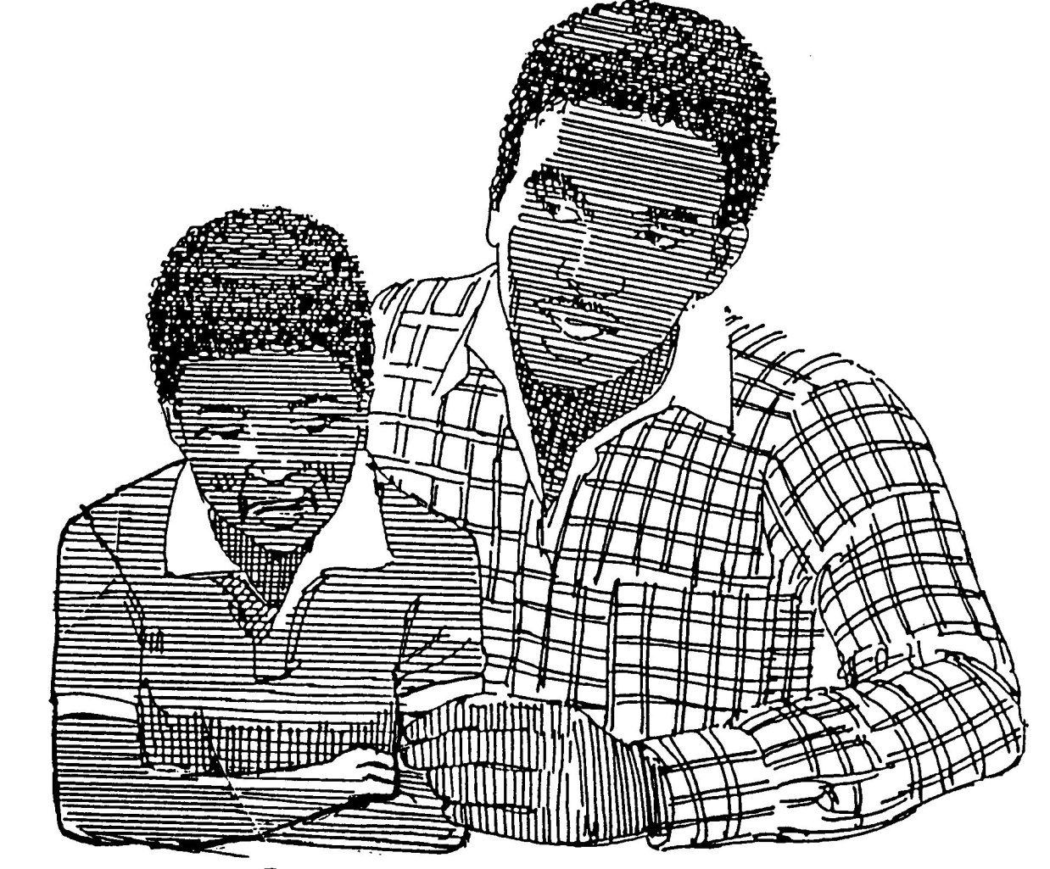

**How to Handle Conflict**

**How to Confront Conflict in a Caring Way**

**By**

**Rev. Dave Batty**

Special appreciation is offered to several sources that provided major influence on the materials included in this course. Turning Point Ministries, Chattanooga, TN; Caring Enough to Confront, by David Augsburger; and Integrity by Henry Cloud. See pages 25-27 for a full listing of resources.

Our website offers additional details on other training available.

Web: www.iTeenChallenge.org

**Global Teen Challenge**

PO Box 511

Columbus, GA 31902

Phone: 706-576-6555

gtc@globaltc.org

Email: DBattyTC@gmail.com

Web: www.Equiptc.org

**Contents**

Overview 4

Key truth on confronting conflict 5

What is your attitude toward conflict? 6

What the Bible says about conflict 6

A. Three common causes of conflict 6

B. Healthy areas where conflict occurs 7

How do you respond to conflict? 7

Five options for dealing with conflict 8

Personal assessment of your past experiences with conflict 9

Basic tools for handling conflict 9

Biblical view on blessing and cursing 11

Second look at your attitude toward conflict 12

Conflict with a healthy person vs. conflict with a dysfunctional person 13

The myth of hidden harmony 14

How to confront conflict in a productive manner 14

How big is the conflict? 15

Abusive situations—sexual abuse, physical abuse, emotional abuse, spiritual abuse 18

How to respond to “Bullies” 20

Learn the basic skills of conflict management 21

What are the basics of negotiation 22

Preventing conflict 23

Getting to the place of peace 24

Resources for further study 25

**How to Handle Conflict**

**How to Confront Conflict in a Caring Way**

**Overview**

We will look at three different aspects of handling conflict

1. What is your attitude toward conflict?
2. What does the Bible say about conflict?
3. How do you respond to conflict?

We will use 4 illustrations to help us connect with conflict.

MCj02458210000[1]

**Illustration #1: Puzzle pieces**

Learning how to respond effectively to conflict is not 3 simple steps. It is more like a puzzle with many different pieces that need to fit together correctly in order for us to experience the satisfaction of a full and rich and complete life.

The puzzle illustration has several shortcomings

1. Conflict is alive, a puzzle is static.
2. Conflict can be dangerous, a puzzle is very safe
3. A puzzle has only one right way to go together—life and conflict is not that simple.
4. Maybe we should imagine a puzzle that if you put a piece in the wrong place it will zap you with an electric shock.

MCj02001610000[1]

**Illustration #2: Walking across a mountain that has an active volcano**

There is fire all around you. How are you going to safely get across the fiery parts?

1. Are you holding on to a rotten shoe lace?
2. Or is the rope you are holding on to strong? A 3 strand rope, woven together will provide something solid to hold on to in the fiery conflict. It will hold you safe even when the bottom falls out under you.

Who is holding on to the other end of the rope? God, or some other person, or have you constructed your own tower—rules for your world?

MCj03971380000[1]**Illustration #3: Who’s driving your conflict car?**

You are driving one car, and the other person in the conflict is driving the other car.

MCj03971480000[1]

So who has the steering wheel? Or does the other person have your steering wheel in their car? Or are you trying to drive both cars?

**Illustration #4: The immune system of your body—your white blood cells**

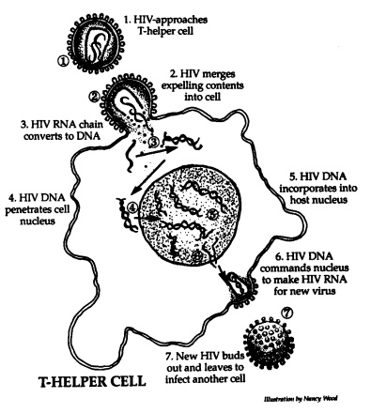

The immune system of your body is designed to keep you healthy. Foreign germs are constantly invading your body. Once in your body, these germs attempt to multiply. Who are these protectors? Your white blood cells.

They exist to keep you healthy. What do they do? They fight!

Who do they fight? Germs, diseases, infections

**Key Truth on confronting conflict:**

We are most useful in confronting conflict when we are not so much trying   
to __________________ another person as we are trying to help them _______ themselves more __________________.

Let’s take a first look at the three aspects of conflict.

What is your attitude toward conflict?

1. Conflict is not __________________.

2. When someone causes conflict, they are not necessarily __________________.

3. Conflict is __________________

__________________

__________________

So Accept it!

4. Learn how to accept conflict as a __________________ of _________________,   
not a __________________ of the __________________.

5. Conflict can be __________________ tension.

6. Conflict can lead all involved to a __________________ understanding

of the _____________ of God and a more __________________ ministry.

7. A biblical approach to resolving the conflict requires all parties involved

to __________________ work for solutions that are filled with ____________ for all.

**What the Bible says about conflict**

**A. Three Common Causes of Conflict**

1. A struggle to understand __________________ __________________ for

the ministry.

Acts 10:9 - 11:18 Segregation vs. integration

Acts 15:1-35 Conditions of salvation

2. __________________ between persons.

Acts 15:36-41 Paul & Barnabas

1 Cor. 1:10-12, 3:4 - 4:6 Fans of Paul & Apollos

3. Sinful __________________

2 Samuel 11 David & Uriah

Matthew 21:12-16 Jesus clearing out the temple

B. Healthy Areas Where Conflict Occurs

1. Over __________________ and __________________

-- “Why are we here” conflicts

-- “What will we do” conflicts

2. Over __________________ and __________________

-- “How will we do it?”

-- “Who will do it?” “When?”

3. Over __________________ and __________________

--any organization over 5 years old has traditions

**How do you respond to conflict?**

**What are some of the typical ways people respond to conflict?**

**Five Options for Dealing with Conflict**

There are different styles of responding to conflict. Conflict management styles are learned, not inherited. You can change your conflict management style. Jesus used each of these different styles of responding to conflict.

1. **Competing: I win—you lose**
   1. Mark 3:1-6 Healing man with withered hand
   2. Matthew 21:12-13 Jesus cleanses the temple
2. **Avoiding: I want out, I’ll withdraw**
   1. John 6:1-15 When the crowds tried to make him king
3. **Accommodating: I’ll give in for good relations**
   1. Mark 5:1-20 Healing demon possessed man in Gadara
   2. John 4:1-38 (v. 16-18) Samaritan woman at the well
4. **Compromising: I’ll meet you halfway**
   1. Matthew 21:23-27 His authority questioned
5. **Collaborating: I can care and confront**

a. John 8:1-11 (v 7, 11) Woman caught in adultery

Every one of these conflict management styles can be used effectively in a biblical way—given the appropriate situation. However, each style can also be used in a manipulative, destructive way.

**Personal assessment of your past experiences with conflict**

Rate each one on a scale of 1 to 10.

____1. How big of a problem has conflict been in your life?

1=small problem 10=big problem

____2. Growing up as a child & teen, how often was conflict a part of your life?

1=conflict was rare 10=lots of conflict

____3. How much pain did conflict cause in your life?

1=little pain 10=lots of pain

____4. How much damage did conflict cause in your life?

1=very little damage 10=lots of damage

**Basic tools for handling conflict**

**A. “I” messages vs. “You” messages**

“You” messages tend to increase conflict by enhancing the other person’s defense mechanisms. These messages cause the other person to feel put down, rejected or unimportant.

Examples of “You” messages

--You just don’t care.

--You are a problem.

--Can’t you ever do anything right?

--You are so stupid!

“I” messages are more effective than “you” messages. “I” messages tell what you feel and how the other person’s behavior is making you feel. This type of message helps to communicate your feelings regarding the other person’s behavior and its effect on you without strengthening the defenses of the other person.

“I” messages deal with facts versus evaluations and judgments. It helps to communicate honesty and openness. “I” messages are less likely to cause harm in the relationship. The self-esteem of the other person is not attacked. An “I” message is different from a “you” message in that you take responsibility for your own feelings.

Examples of “I” messages

--I feel angry because. . . . .

--I feel that you don’t care because. . . .

--I feel hurt because. . . . . .

**B. What is your level of listening?**

**Level 1: Focused on myself**

1. Internal
2. My thoughts
3. My judgments
4. My filters
5. How it relates to me
6. My interests
7. My agenda

**Level 2: Focused on others**

1. Their feelings
2. Their thoughts
3. Their conclusions
4. Their filters
5. How it relates to the person I am listening to
6. Their interests

**C. Ways of confronting conflict without being judgmental** John 3: 17

**1. Focus your feedback on**__________________**, not the actor.**

This gives the person freedom to change his behavior without feeling personal rejection.

Example: “When someone criticizes people who are not present, as you were doing a moment ago, I get uptight. I would encourage you to say what you have to say to the person.”

**2. Focus your feedback on** __________________**, not your conclusions.**

Do not comment on what you think, imagine, or speculate, but on what you have actually seen or heard. Conclusions cause the other person to be defensive.

Example: “You are not looking at me and not answering when I speak. Please give me both attention and answer.”

**3. Focus your feedback on** __________________**, not judgments.**

Do not comment on another person’s behavior as nice or rude, right or wrong. Instead, give a clear, accurate description in neutral language. When the other person senses that you are judging them, they often will break off open communication.

Example: “I am aware that your reply to my request for information was silence. Please tell me what this means.”

**4. Focus your feedback on ideas, information, and alternatives,   
not on** __________________ **and** __________________**.**

Do not tell the other person what to do, even if they ask, “What should I do?” They need to decide what will be their solution. Help them see all the facts that are relevant to the problem. The more options available, the less likely is a premature solution.

Example: “I’ve several other options that you may have thought about, but let me run them by you again.”

**5. Focus your feedback on what and how, not** ___________**.**

“Why” focuses on motives, and often leads to excuses and rationalizations. “Why” is judgmental. “What” and “how” related to observable actions, behaviors, words and tone of voice. Children under 12 are not able to understand intentions, so do not ask them “Why did you do that?” When they say, “I don’t know,” they are telling the truth.

Example: “Here is where we are, let’s examine it.”

**Key Truth on Confronting Conflict**

We are most useful in confronting conflict when we are not so much trying   
to change another person as we are trying to help them see themselves more accurately.

**Biblical view on blessing and cursing**

Conflict and cursing are the twins in many people’s lives.

**1. God’s promise to Abraham** Genesis 12:1-3

Those who bless you, I will bless

Those who curse you, I will curse.

**2. The teachings of Jesus on blessing and cursing**

Luke 6:27-28 NIV

27But I tell you who hear me: Love your enemies, do good to those who hate you,   
28bless those who curse you, pray for those who mistreat you.

**Second look at your attitude toward conflict**

**1.** __________________ **conflict**

Do not run from it. Do not be afraid to deal with the negative.

Does conflict stress you out?

Stress depletes brain chemicals

**2. My eyes are toward** __________________

Conflicts are the setting for problem solving—so we can grow!

God uses problems to teach us to rely on Him, not on ourselves

2 Corinthians 1:8-10 NIV

8We do not want you to be uninformed, brothers, about the hardships we suffered in the province of Asia. We were under great pressure, far beyond our ability to endure, so that we despaired even of life. 9Indeed, in our hearts we felt the sentence of death. But this happened that we might not rely on ourselves but on God, who raises the dead. 10He has delivered us from such a deadly peril, and he will deliver us. On him we have set our hope that he will continue to deliver us.

If I’m not growing, I’m simply in a maintenance mode in life.

**3. The essential need for respect toward other person, vs. responding with “you idiot!”**

Make the problem the focus, not the other person.

Deal with the problem without becoming the problem.

**Conflict with a healthy person vs. conflict with a dysfunctional person**

What sets up a person to do poorly in handling conflict?

--bullies, abusers,

--Hurt people hurt others.

So what are you? Four options

You are healthy and The other person is healthy

You are healthy and The other person is unhealthy

You are unhealthy and The other person is healthy

You are unhealthy and The other person is unhealthy.

**Unhealthy person Healthy person**

1. Focuses on whose fault is it. 1. Focuses on how we can solve things

What can I do to make it work?

2. Blames others 2. Find acceptance and love in your weaknesses and failures.

2 Corinthians 12:7-10

3. You need to change! 3. Take ownership of your own failures &

imperfections.

(What percentage were you at fault?)

4. Makes excuses 4. Takes responsibility for the situation.

**Unhealthy person Healthy person**

5. I see myself as good 5. Give up on being perfect & work hard to

improve.

6. Denial 6. Honest—not taking more or less

Only taking the truth.

7. I care about me 7. I care about you and me.

The bully Romans 12:1

8. The martyr complex 8. We are to be a living sacrifice, not a dead one.

**The myth of Hidden Harmony**

In the book, *When Talking Makes Things WORSE!* the author, Dr. David Stiebel, discusses a common myth people have when it comes to conflict.

“Deep down, we all agree. There is no conflict, only poor understanding. If only we understand each other, we’ll agree. The president’s twist on it was: If only you understand me, we’ll agree.”

Take a minute and think of the different conflict situations you have been part of recently. How often have you carried this idea, “If you would just listen to me, I am sure you would leave agreeing with me.”

This only works if the real cause of the conflict is a misunderstanding. If however, the conflict is rooted with a basic disagreement between the two parties involved, then talking will not solve it. In fact, the opposite may happen. The more they talk, the angrier they may become.

We can help overcome this myth of hidden harmony by coming back to our key truth:

*We are most useful in confronting conflict when we are not so much trying to change another person as we are trying to help them see themselves more accurately.*

**How to confront conflict in a productive manner**

**1. Are you ignoring the white elephant in your living room?**

**2. You get what you tolerate.**

If you do not confront conflict, and instead you tolerate problems, that’s what you will get—more problems.

Those who fail to confront leave success on the table, they allow problems to stop them.

**3. You can confront well or you can confront poorly.**

If you fail to confront, you lose.

But if you confront poorly, you also lose.

**4. Confront in such a way as to preserve the relationship with the other person.**

1 Peter 4:8 NIV

Above all, love each other deeply, because love covers over a multitude of sins..

**5. Stay connected with the person—conflict resolution is a process**

Two parts to this process:

1. Solve the problem
2. Focus on healthy living

**6. Forgiveness**

Forgiveness is giving up my demands on how this person should be punished for the wrong things this person did against me. I allow God to deal with this person.

To forgive does not mean this person can continue to sin against me.

To forgive is different than to restore the relationship.

To forgive does not mean I must trust this person.

Forgiveness enables me to move ahead with my life, and not be held back by my past.

Let the bad stuff go! Cancel the debt they owe you.

“People who have not ever really faced their own misdeeds, owned their own mistakes toward others, and received forgiveness and made amends rarely have forgiveness toward others. They still think they are morally superior and lord their superiority over the one who fail them in some real or imagined way. But if they have been honest about their own failures and been accepted for those, then they are more humble and able to forgive other imperfect people like themselves.” (Quoted from Integrity, by Henry Cloud, page 195)

**How big is the conflict?**

We face a major challenge in dealing with conflict in our lives in this area of determining how big an issue is a conflict situation. If you are a healthy person, every conflict is not a catastrophe.

Illustration of a cut on your finger. Every time you touch that injured area, you feel great pain. When you were healthy, that same touch would not cause any pain, nor would you even notice the touch. But since you have an injury now, even the slightest touch causes great pain.

If every conflict with a person(s) is causing you great pain, maybe one of the main issues is that you are a wounded person. Once you experience healing, you will not feel nearly as much pain with the same kinds of conflict situations.

**Are the conflict issues “mountains” or “pebbles”?**

**1. Examples in the Bible**

**A. God asked Abraham to kill his son Isaac as a sacrifice to God.**

Mountain or pebble?

Genesis 22:1-18

Genesis 22:1-3 NIV

1 Some time later God tested Abraham. He said to him, “Abraham!” “Here I am,” he replied.

2 Then God said, “Take your son, your only son, Isaac, whom you love, and go to the region of Moriah. Sacrifice him there as a burnt offering on one of the mountains I will tell you about.”  3 Early the next morning Abraham got up and saddled his donkey. He took with him two of his servants and his son Isaac.

Hebrews 11:17-19 NIV

17By faith Abraham, when God tested him, offered Isaac as a sacrifice. He who had received the promises was about to sacrifice his one and only son, 18even though God had said to him, “It is through Isaac that your offspringwill be reckoned.” 19Abraham reasoned that God could raise the dead, and figuratively speaking, he did receive Isaac back from death.

**B. God says more than once, “Stop crying. Get up and go and do ……..”**

**Mountain or pebble?**

**C. Paul’s description of the trials he faced. Mountain or pebble?**

2 Corinthians 1:8-11 NIV

8We do not want you to be uninformed, brothers, about the hardships we suffered in the province of Asia. We were under great pressure, far beyond our ability to endure, so that we despaired even of life. 9Indeed, in our hearts we felt the sentence of death. But this happened that we might not rely on ourselves but on God, who raises the dead. 10He has delivered us from such a deadly peril, and he will deliver us. On him we have set our hope that he will continue to deliver us, 11as you help us by your prayers. Then many will give thanks on our behalf for the gracious favor granted us in answer to the prayers of many.

2 Corinthians 4:16-18 NIV

16Therefore we do not lose heart. Though outwardly we are wasting away, yet inwardly we are being renewed day by day. 17For our light and momentary troubles are achieving for us an eternal glory that far outweighs them all. 18So we fix our eyes not on what is seen, but on what is unseen. For what is seen is temporary, but what is unseen is eternal.

One way to get a better handle on this issue is to ask yourself, “How big an issue will this be 10 days from now, or 10 years from now?”

**2. Generational problems Mountain or pebble?**

What patterns in handling conflict have been passed down by your family?

What major weaknesses, addictions, lifestyle patterns have been passed down in your family?

Grandfather >>>>> Father >>>>> Son >>>>> Future generations???

**3. Is the conflict issue painful, but not sinful? Mountain or pebble?**

Do the problems created force you to sin?

Is this worth losing your job?

**4. Are the others failing to see God’s call on your life?** **Mountain or pebble?**

Norm & Ginny Cadarette and their desire to be involved in AIDS ministry.

Norm had AIDS in the late 1980s.

Pastor said, “Wait until you are healed, then you can go public.”

After 2 years they went to another church which embraced and supported their new ministry.

**5. Abusive situations—sexual abuse, physical abuse, emotional abuse, spiritual abuse**

**Mountain or pebble?**

The person being abused is often wounded, and not seeing the situation from a balanced perspective.

Abuser is often manipulative

—”if you tell anyone, I will kill you, or your family”

—you really wanted it

—the abuser is a very charming person

**Principles of handling an abusive situation.**

**1. God values your life—you are precious to Him.**

**2. God has harsh words for abusers**

Matthew 18:6 NIV

But if anyone causes one of these little ones who believe in me to sin, it would be better for him to have a large millstone hung around his neck and to be drowned in the depths of the sea.

**3. Principle of the greater value**

Example: I can’t get that child out of the street because the cross walk sign says, “Don’t walk.”

Example: Herod promises to give the daughter of Herodias whatever she wants. She then asks for the head of John the Baptist. He chooses to honor his word to her, rather than lose face, and save John’s life. (Matthew 14:6-11)

Example: The two greatest commands in Bible are to love. The abuser is breaking both laws.

Example: 1 Corinthians 7:12-16 Paul’s teaching on staying with your unbelieving husband or wife. Abuse changes the situation.

**4. Principle of safe boundaries “Tough love”**

**5. Can you separate the truth from the lies?**

**6. When the solution creates more conflict Mountain or pebble?**

A. Mother with a son who is using drugs.

Her rules for him—he rejected them and moved out of the home.

Right solutions do not always produce peaceful results.

You cannot guarantee the response of the other person. They choose their responses.

B. Daughter ends up in jail and calls home, “Dad, please bail me out of jail.” His response, “No, but when you get out of jail, you are welcome to come home.”

She came home angry, but never went to jail again.

**7. How to respond to “Bullies” Mountain or pebble?**

Rudy Giuliani’s book Leadership has a chapter on how to deal with bullies. His example dealt with union leaders.

Some bullies are sweet and charming, but they are still a bully.

They are only interested in getting what they want, with no regard for how others are affected by the consequences.

You’ve got to speak the language they understand, and take the actions they understand.

The issue of fear: courage is needed in the face of their intimidation.

Past trauma at the hands of a bully and it present impact in your life.

Issue of revenge

Issue of forgiveness with the bully.

So who has your steering wheel? (Remember the illustration at the beginning of this session.)

Learn the Basic Skills of Conflict Management

1. Learn to recognize and address a conflict in its __________________ stage.

--put yourself in other people's shoes

--learn their conflict management style

2. Keep everyone focused on the issue.

3. Provide the 3 “P”s of Conflict Management

A.__________________ --to disagree without feeling guilty.

This gives everyone room to function.

Defuses the tension.

B.__________________ --enable each party to state their position with as much strength and clarity as possible.

Why? --you get the best facts on the table

--you create a bigger arena from which to draw solutions

C. __________________ --do not allow judging or needless hurting.

Cut off personal attacks

4. Enable ____________ parties to see a way out of the conflict by suggesting options to their present positions and goals.

--Build on what you agree on

--You can't do this unless you have first allowed the three “P”s.

5. Work to turn every conflict into a ____________________________ situation.

Involve __________________ in this process.

What people help to create, they support.

They tend to resist what is thrust on them.

**What are the basics of negotiation?**

1. Willingness to listen.

2. Willingness to take sides.

3. The courage to publicly place value on issues.

--How important is each issue in this conflict?

4. Willingness to discuss various solutions before deciding which one(s) I will accept.

“Negotiate in good faith.”

5. Willingness to establish policies or change present procedures.

6. Willingness to disagree.

“It’s okay if we don’t agree.”

7. Willingness to establish and agree on common goals and priorities.

8. Willingness to be accountable.

Willingness to accept the consequences of my behavior.

9. Willingness to work to save face for everyone involved.

Some conflict situations involve people who have clearly been wrong in their behavior. To resolve this does not mean we negotiate a cover-up of their sins.

**Preventing conflict**

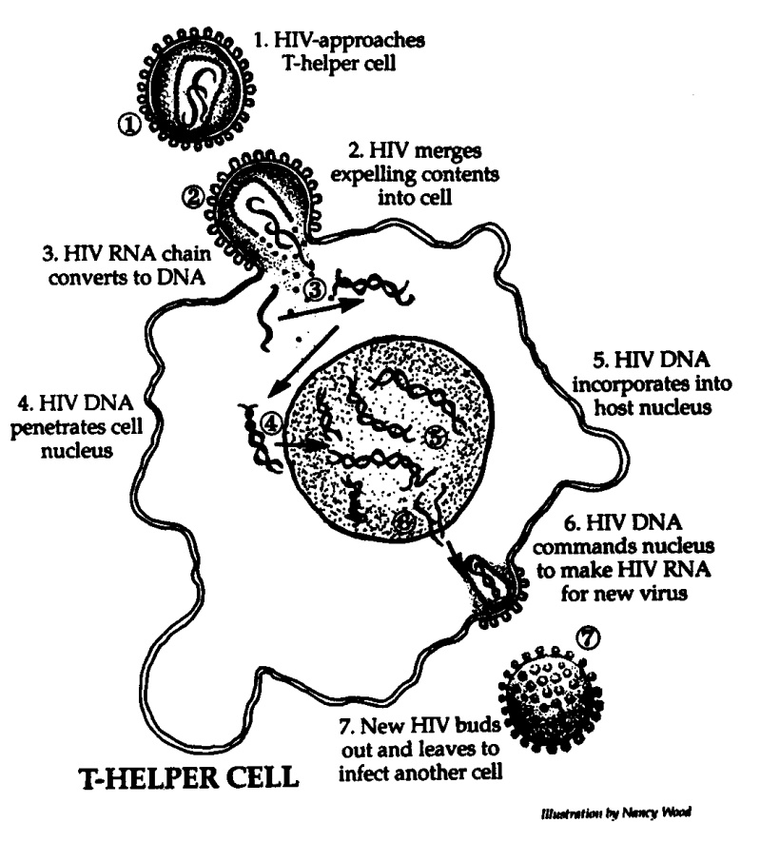

The best way to solve a problem is to prevent it.

1. Illustration of your immune system

HIV virus attacks the immune system and turns the white blood cells into manufacturing more HIV virus. The cells which should be protecting us become a factory for producing more viruses which will destroy our health.

Healthy living is the best prevention approach. Our focus should not be to simply avoid conflict, but to face each problem with a positive attitude. We need to learn the lessons God wants us to learn with each problem that comes our way.

However, conflict is a normal, natural, neutral part of all our lives.

2. We have to be strong enough to disappoint people, and be more than a people pleaser.

Have the courage to say “No”

3. Issue of delayed gratification

4. No pain, no gain

5. Pay the price to get the resolution.

**Getting to the place of peace**

1. God has promised He will never leave us or forsake us. Hebrews 13:5

2. We can have inner peace, even when there are storms in our lives.

John 14:1-4 NIV

1 “Do not let your hearts be troubled. Trust in God; trust also in me. 2In my Father's house are many rooms; if it were not so, I would have told you. I am going there to prepare a place for you. 3And if I go and prepare a place for you, I will come back and take you to be with me that you also may be where I am. 4You know the way to the place where I am going.”

John 16:33 NIV

“I have told you these things, so that in me you may have peace. In this world you will have trouble. But take heart! I have overcome the world.”

John 14:27 NIV

Peace I leave with you; my peace I give you. I do not give to you as the world gives. Do not let your hearts be troubled and do not be afraid.

2 Timothy 1:7 NIV

For God did not give us a spirit of timidity, but a spirit of power, of love and of self-discipline.

**When do I need to start changing the way I respond to conflict?**

**Resources on conflict**

Caring enough to confront. David Augsburger (Regal Books, 1973, 1981).

Integrity: The Courage to Meet the Demands of Reality. Henry Cloud. Chapter 10, “Eating Problems for Breakfast,” deals with conflict. (Harper Collins, 2006).

The Peacemaker, by Ken Sande (www.HisPeace.org)

Peacemaking: Responding to Conflict Biblically. This is a small group study guide and leader’s guide by Jimmy Lee and Brad Rymer. (www.LivingFree.org, Turning Point, Chattanooga, TN, 2000) Based on the book The Peacemaker, by Ken Sande.

This small group study helps us understand conflict and our response to it. It also helps to see conflict as an opportunity to glorify God. This study contains methods of self-examination; it includes suggestions about when and how to confront someone. This study offers a biblical approach to negotiating and dealing with unreasonable people.

Getting to Yes: Negotiating Agreement Without Giving In. 2nd Edition. Roger Fisher and William Ury and Bruce Patton (Penguin Books, 1981, 1991)

Leadership. Rudy Giuliani. Chapter 12, Stand up to Bullies. (Mirimax Books, 2002)

When Talking Makes Things WORSE! Resolving Problems When Communication Fails. Dr. David Stiebel is the author of the book/audiobook. (Whitehall & Nolton, 1997).

**Other resources for further study**

*Counseling for Relapse Prevention* by Terence T. Gorski & Merlene Miller (Herald House—Independence Press, Independence, MO, 1982).

*The Genesis Process: A Relapse Prevention Workbook for Addictive/Compulsive Behaviors*, by Michael Dye and Patricia Fancher. (Genesis Addiction Process & Programs, 25363 Rodeo Flat Rd., Auburn, CA 95602 Phone: 530-269-1072, web: www,genesisprocess.org)

*The Life Model: Living from the Heart Jesus Gave You: The Essentials of Christian Living*, by James G. Friesen, E. James Wiler, Anne M. Bierling, Rick Koepcke, and Maribeth Poole. Workbook also available. These can be ordered through CARE Packaging, 9731 S M-37, Baldwin, MI 49304, phone 231-745-0500.

Forgiving our parents, forgiving ourselves. David Stoop

Moving beyond the pain of the past. Sandra Wilson

Recovery for adult children of alcoholics and dysfunctional families. Sandra Wilson

Released from shame. Sandra Wilson

Forgive and forget. Lewis Smedes

The art of forgiveness. Lewis Smedes

The lies we believe. Chris Thurman

Compelled to Control: Recovering intimacy in broken relationships. J. Keith Miller. Health Communications, Inc.

Changes that heal: How to understand your past to ensure a healthier future. Dr. Henry Cloud. Zondervan.

Boundaries: When to say “Yes,” when to say “No,” to take control of your life. Dr. Henry Cloud and Dr. John Townsend. Zondervan. A separate workbook is also available for this book.

Boundaries in Marriage. Dr. Henry Cloud and Dr. John Townsend. Zondervan. A separate workbook is also available for this book.

Boundaries with kids. Dr. Henry Cloud and Dr. John Townsend. Zondervan. A separate workbook is also available for this book.

Boundaries Face to Face: How to have that difficult conversation you’ve been avoiding.   
Dr. Henry Cloud and Dr. John Townsend. Zondervan.

Another chance. Sharon Wegscheider

Anger is a choice. Tim LaHaye and Bob Phillips. Zondervan.

Safe People: How to find relationships that are good for you and avoid those that aren’t. Dr. Henry Cloud and Dr. John Townsend. Zondervan. A separate workbook is also available for this book.

Healing for Damaged Emotions. (Study guide included). David Seamonds & Beth Funk. Life Journey.

Looking good outside, feeling bad inside. Curtis Levang. (YWAM)

The following resources by Dave Batty are available at the website [www.iTeenChallenge.org](http://www.iTeenChallenge.org)

[**Boundaries in Your Mind**](javascript:openpopup_27b5('../Boundaries_in_your_mind_web.pdf'))

[**Dealing With Shame**](javascript:openpopup_27b5('../Dealing_with_Shame_Newsltr_web.pdf')): How do I know if it is from God?

[**Delusion, Denial, Deception:**](javascript:openpopup_27b5('../Delusion_Newsltr_2nd_edition_2.pdf')) Overcoming the trap of delusion, denial, and deception.

[**Enabling**](javascript:openpopup_27b5('../Enabling_Newsltr_2nd_edition.pdf'))**:** Are you offering the wrong kind of help to your loved ones?

[**Facing Your Problems**](javascript:openpopup_27b5('../Facing_Your_Problems_Newsltr_2nd_edition.pdf')): The path to pure joy.

[**Finding Hope**](javascript:openpopup_27b5('../Finding_hope_PDF.pdf'))**:** Finding hope in the midst of life’s problems.

[**God’s School of Life Training**](javascript:openpopup_27b5('../God_s_School_Newsltr_2nd_Ed_Web.pdf')): How good a student are you in God’s school of life training?

[**Living with Guilt**](javascript:openpopup_27b5('../Living_with_Guilt_2nd_edition_web.pdf'))**:** Are you living with guilt that doesn’t belong to you?

[**Mending a Broken Heart**](javascript:openpopup_27b5('../Mending_a_Broken_Heart_web_PDF.pdf'))**:** What are the steps to mending a broken heart?

[**Raise the Bottom**](javascript:openpopup_27b5('../Raising_the_Bottom_Newsltr_2nd_edition.pdf'))**:** You’ve heard, “They have to hit bottom before they get help.” Why not raise the bottom?

[**Renewing Your Mind**](javascript:openpopup_27b5('../Renewing_your_mind_WEB.pdf'))**:** How can a person get rid of inappropriate thoughts? How can you change the way you think?

[**Returning to Joy**](javascript:openpopup_27b5('../Return_to_Joy_web_screen.pdf')): Training your brain for the life skill of returning to joy.

[**They Don’t Want Help**](javascript:openpopup_27b5('../They_don_t_want_help.pdf'))**:** What can you do for your loved one when they don’t want help?

[**What are Your Triggers?**](javascript:openpopup_27b5('../Triggers_Newsltr_2nd_edition.pdf'))What are those things that trigger a response in your life? Do you let these triggers pull you down a destructive path?

[**When People Hurt You**](javascript:openpopup_27b5('../Hurts_Newsltr_PM_2nd_edition_web.pdf'))**:** How can you respond to those who betray or hurt you? Where does revenge fit in?

[**When Will Your Miracle Come?**](javascript:openpopup_27b5('../When_will_miracle_come_WEB.pdf'))How can I receive a miracle from God?

Visit the website for additional helps & resources: **www.iTeenChallenge.org**

**Global Teen Challenge**

**PO Box 511**

**Columbus, GA 31902**

**706-576-6555**

**Email: DBattytc@gmail.com**

**Web: www.Globaltc.org**