What is GTC Bridge?

GTC Bridge is an online learning platform where Teen Challenge staff can take eLearning courses for staff training and professional growth. The training courses may also include quizzes and checkpoints to test one’s knowledge. Some courses offer certification.

Currently, training is offered in the following categories:
New Staff Orientation
PSNL - GSNL Teacher/Facilitator Training
Discipleship & Direct Care Helping Skills
Personal & Spiritual Growth
Program Development
Communication & Marketing
Fund Raising

Popular courses include The DNA of Teen Challenge, Forgiveness, Foundations (History of Teen Challenge), PSNL Teacher Certification, and Compassion without Compromise.

GTC Personal Studies Teacher Certification - English, Spanish & Russian
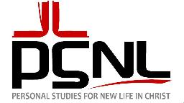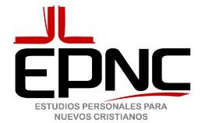

We offer the Personal Studies Teacher Certification available as an online course using our Bridge training platform. Upon successful completion, staff will be a certified Personal Studies teacher.

For more info or to enoll write to gtc@globaltc.org.

