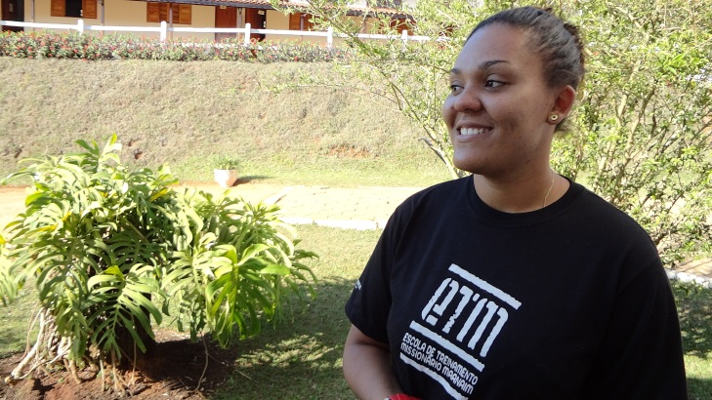
My name is Geane and I am 23 years old.
I was raised going to church and walked as God wanted, and I was obeying God’s orders and being submissive to my parents. I was involved in ministry, playing the saxophone and doing theater. My life was going well.
I started to have problems and began serving the devil about the age of 11 as a result of sexual abuse as a child. Because of this open wound, the devil began to affect my life, and I began to act differently with my family at home.
I started to get involved with many women and began to wear men’s clothing and live like a man. When people saw me on the street they thought they saw a boy. I started using drugs and also got involved in trafficking. I didn’t feel I needed to change my behavior because I felt that my parents would stick by me and were with me no matter what. But I was a slave to the devil for a long time. My family began to suspect what I was doing and often asked where I got my drugs, but I didn’t say anything.
Then one day I consumed almost 20 grams of cocaine and was even thinking of taking my life. This was because of a relationship with a girl that I had for a year. I also began using drugs more and more each day. I began using marijuana, cocaine, LSD. That same day, a friend came to see me, and the following morning she took me away from the drug scene, never again to use drugs!
I decided to go back home, but my mother was surprised and frightened to have me back home. She had already decided that I was never coming back, yet this was the day that God gave me, my last chance to survive the life of drugs.
I changed my clothes and went to bed, and I heard a voice saying to me, “Today I will show you who I AM”. I thought to myself, I’m still filled with cocaine I must be hearing voices, but it was God speaking to me like when He showed His power when He raised Jesus from the dead.
And really He did show me His power, but at the same time, the devil began to torment me from all night long. The enemy wanted to kill me that day. He tried 18 times. My mother panicked and pleaded with others who she trusted and asked them to come to the house to help me. These people came and prayed that I would be delivered. One woman said to me: “Geane, today the Lord is saying that this is your last chance.”
Immediately I felt God helping me inside. I then entered Teen Challenge Maanaim, where God continued to work in my life. I went through the first phase just fine, but it was in the second phase of the program that not only did God transform me, but he directed me to live a life of integrity and holiness. My counselor in Personal Studies gave me a scripture from Deuteronomy that said God abhorred women wearing men’s clothes. I went at once and gave three bags of men’s underwear to my counselor. My complete deliverance came as I studied a lesson on forgiveness and I forgave those that hurt me as a child.
I graduated from ETM (Teen Challenge) but stayed on as a staff member. When I visited my family, people did not recognize that I was the same person. I began to tell people about Jesus sharing what he did in my life and that God really existed.
I now have been free from drugs and homosexuality for one year! Glory to my Lord!
Thank you to Teen Challenge Maanaim for welcoming me and believing in me.

